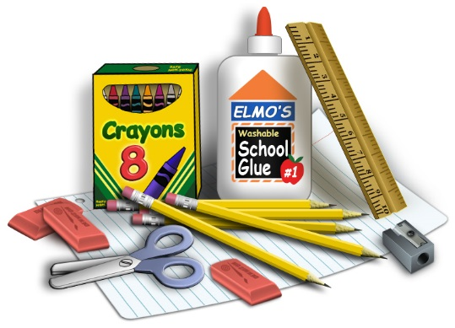
Resource Room Supply Needs and Wish list
Ms. Souza, Mrs. Maynard, and Ms. Pearce
Room 315

NEEDS
- Two pocket folders with and without prongs
- Labels of various sizes
- Fine tip dry erase markers
- Colored printer paper
- 3 ring binders (1/2 Inch to 2 inch)
- Binder divider tabs
- Card Stock Paper (white and colored)
- Laminating pouches
- Assorted size/color sticky notes/tabs
- Colored index cards * 3 x 5
- Items for our treasure box (reinforcements that your child likes)
- Snacks, Candy, and Juice Boxes
- Tissues, Baby Wipes, Zip Lock Baggies
- Headphones for computer and ipads
- Sensory items
- Assorted color Sharpies and pens
WISH LIST
- Social Skill story books (Amazon Prime)
- Games – both academic and nonacademic – social skill building and collaborative
- iTunes Gift Cards for learning apps
- Scholastic Subscription for StoryWorks Junior
- Horseshoe Activity Table & Flexible Seating
- Mini ipads or Google Chromebooks for student use & cases
We are always in need of supplies and teaching resources. Some of our favorite vendors include…..
Amazon, Office Max or Depot, Scholastic, Teach Me, Stones Educational Store, Walmart, Target, Lake Shore Learning, Google Apps, School Specialty, Teachers Pay Teachers, etc…

Amazon Prime Supply List - http://a.co/1m9u2Dj

Thank you in advance for anything donated to our classroom!
Checkout our Donor’s Choose Page. We will be setting up a couple of grants throughout the year.
http://www.donorschoose.org.learnwithsouza

